Planting Your Seedling
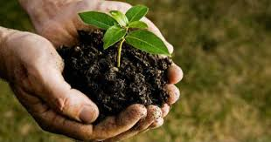

Take Care of the Roots
- Soak in water for 1-2 hours before planting
- Do not let roots dry out – if you cannot plant immediately, make sure roots are completely covered in damp paper towels

Prepare a Planting Area
- Generally recommended to plant your seedling in a pot for its first summer & transplant to ground in the fall
- Select a location where the seedling will have adequate space to grow into a full sized tree both above and below the ground (paying special attention to utility wires)
- Dig a hole slightly larger than the roots spread out

Plant Your Seedling
- Place the root collar (the place where the roots join the stem) at soil level
- Partially fill the hole, firm the soil, and water the plant
- Fill the rest of the hole, water again, and add loose soil and mulch
- Make sure to break up all the soil clods and to water sufficiently to prevent air pockets. Fertilizer is not needed at this time.

Caring For Your Seedling
- Water deeply and regularly (one deep watering a week is enough)
- Water during dry periods for the first three years

Happy Earth Day 2018 from the Inova Going Green Team!

Questions? Email gogreen@inova.org.

